**BALDIVIS SECONDARY COLLEGE**

** APPLICATIONS - Unit 3 & 4**

**2018 Test 2- Sequences**

Student Name ______________________ Teacher Name ______________________

**Time allowed for this task:** 55 minutes, in-class, test conditions.

Section 1: 15 minutes + 2 minutes reading time

Section 2: 35 minutes + 3 minutes reading time

**Materials required:** Section 1 Calculator free section (17 marks)

Standard writing equipment

SCSA Formula Sheet

Section2 Calculator assumed section (30 marks)

Calculator (to be supplied by the student)

SCSA formula Sheet

One page A4 (double sided) hand written notes

**Other materials allowed:** Drawing templates

**Marks available:** **47 marks**

**Task Weighting: 6%**

**Question 1 (11 marks: 4, 4, 3)**

1. A geometric sequence has T3 = 4 and T6 = 32
2. Determine the recursive rule.
3. By determining the **explicit** rule, calculate the 5th term
4. An arithmetic sequence has T3 = -5 and T6 = 4
5. Determine the recursive rule.
6. By determining the **explicit** rule, calculate the 5th term
7. For the following sequence determine the recursive rule and T7

|  |  |  |  |  |
| --- | --- | --- | --- | --- |
| T1 | T2 | T3 | T4 | T5 |
| 4 | -8 | 16 | -32 | 64 |

**Question 2 (6 marks: 2, 2, 2)**

1. An arithmetic sequence has T3 = 9 and a common difference of 2. Determine the twelfth term.
2. The following graph depicts a geometric sequence.

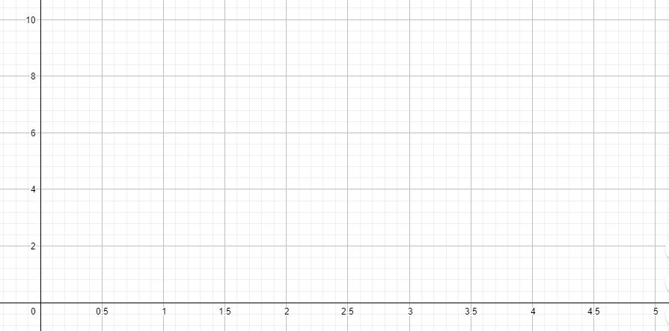

Determine the rule to find the nth term

1. The following graph depicts a geometric sequence

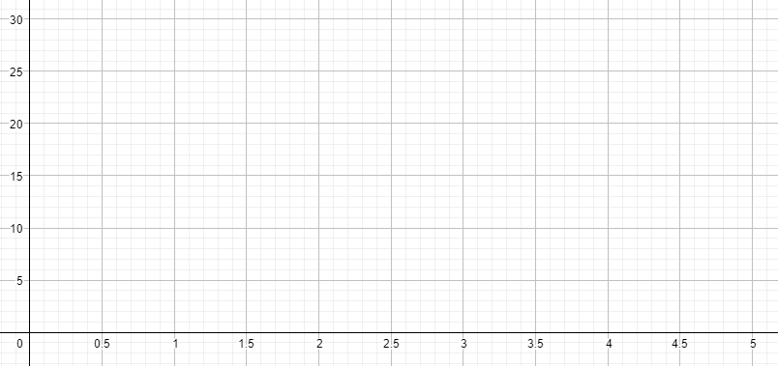

Determine the 8th term

**End of non-calculator Section**

 **Section 2 - Calculator Allowed**

**Total marks – 30 Working time 35 minutes**

**Question 3 (10 marks: 6, 2, 2)**

Consider a sequence which is generated as follows:

Tn+2 = Tn+1  + 2*x* – 3, T2 = 3*x* -1

1. Write simplified expressions for the first four terms of the sequence
2. Is this a geometric, arithmetic or linear sequence? Justify your answer
3. If 2T1 = T2 + 2 calculate the value of *x*

**Question 4 (3 marks)**

A geometric sequence is such that T10 = - 1536 and T15 = - 49152. Find the first term and the common ratio

**Question 5 (4 marks: 2, 2)**

For the following sequences

1. State whether the relationship is arithmetic or geometric
2. Find the 40th term
3. Tn = 8 x (1.1)n b) Tn = 80 – 3n

**Question 6 (5 marks: 1, 1, 2, 1)**

A house is valued each year over the course of 5 years

|  |  |  |  |  |  |  |
| --- | --- | --- | --- | --- | --- | --- |
| Year | 1 | 2 | 3 | 4 | 5 | 6 |
|  | $450000 | $477000 | $505620 | $535957.20 | $568114.63 | $602201.51 |

1. Show that the house follows a geometric sequence
2. Find the annual rate of increase as a percentage
3. Write a general rule for the terms in the sequence
4. Find the value of the house in year 30

**Question 7** **(8 marks: 3, 2, 2, 1)**

On a private property in Rosa Brook, the owner releases a population of 200 marron into her dam. She expects that the marron population will grow at a rate of 20% per year and she plans to capture 50 to eat each year.

1. Write a first order linear recurrence relation to model this situation
2. Plot the terms of the sequence on the axes below



1. Describe what is expected to happen to the population of marron over time
2. How many marron should the owner harvest each year to achieve a ‘steady state’ situation?

**End of test**